The Islamia University of Bahawalpur
Review Article | Research Methods
Explainable Identification of Human vs. Large Language Model (LLM) Generated Text: A Systematic Review
By: Jawwad Ahmad | F25NDOCS3W04013 | MSCS 2nd Semester
Supervisor
Dr. Ahmad Niaz
Assistant Professor, Computer Science Department

Abstract
The rapid proliferation of Large Language Models (LLMs) such as GPT-4, Llama, Claude, and Google Gemini has intensified the need for reliable automated detection of machine-generated text across high-stakes domains including academia, journalism, and medicine. While transformer-based detection systems have achieved state-of-the-art classification accuracy, their opaque decision-making processes undermine user trust and institutional accountability. This review addresses that limitation by systematically examining the intersection of AI-generated text detection and Explainable Artificial Intelligence (XAI), focusing on the post-hoc local explanation methods LIME (Local Interpretable Model-agnostic Explanations) and SHAP (SHapley Additive exPlanations).
Following the PRISMA framework, a systematic search of four electronic databases yielded twelve studies published between 2023 and 2026. Findings are synthesized across three thematic clusters — stylometric and classical machine learning approaches, transformer-based deep learning methods, and multi-label attribution frameworks — and analyzed against four research questions addressing detection accuracy, XAI effectiveness, cross-domain generalizability, and structural limitations.
The review's principal positive finding is convergent validity: LIME and SHAP consistently identify grammatical standardization, formulaic transitional language, low lexical entropy, and suppressed epistemic hedging as the most discriminative markers of LLM authorship, regardless of the underlying detection architecture. The review also documents an unresolved adversarial paradox — XAI explanations that make detection transparent simultaneously enable targeted evasion — and identifies five structural research gaps spanning adversarial robustness, XAI evaluation standards, fairness for non-native writers, cross-domain generalization, and multilingual coverage.
Keywords: AI-generated text detection, explainable artificial intelligence, LIME, SHAP, large language models, stylometry, transformer models, natural language processing, systematic literature review

1. Introduction
The emergence of Large Language Models (LLMs) such as GPT-4, Llama, Claude, and Google Gemini has redefined the boundaries of automated text generation. These systems produce output that is grammatically fluent, contextually coherent, and stylistically indistinguishable from human prose — a capability that introduces serious risks across academic, journalistic, legal, and medical contexts. As a result, automated detection of AI-generated text has emerged as one of the most pressing challenges in contemporary Natural Language Processing (NLP).
Early detection systems relied on perplexity scores, burstiness metrics, and stylometric indices. These were rapidly eclipsed by transformer-based architectures such as RoBERTa and DistilBERT, which achieved significantly higher classification accuracy. The HULLMI framework (Joshi et al., 2024) demonstrated that fine-tuned transformers could outperform conventional classifiers across multiple LLM sources and domains. However, improved accuracy has in many ways compounded the underlying challenge.
Transformer-based detectors operate as "black boxes" — arriving at decisions through internal representations inaccessible to end-users. An educator cannot discipline a student, a journal cannot reject a manuscript, and a legal body cannot challenge evidence on the basis of a system whose reasoning is opaque. The field has therefore turned toward Explainable Artificial Intelligence (XAI) as an essential complement to detection performance.
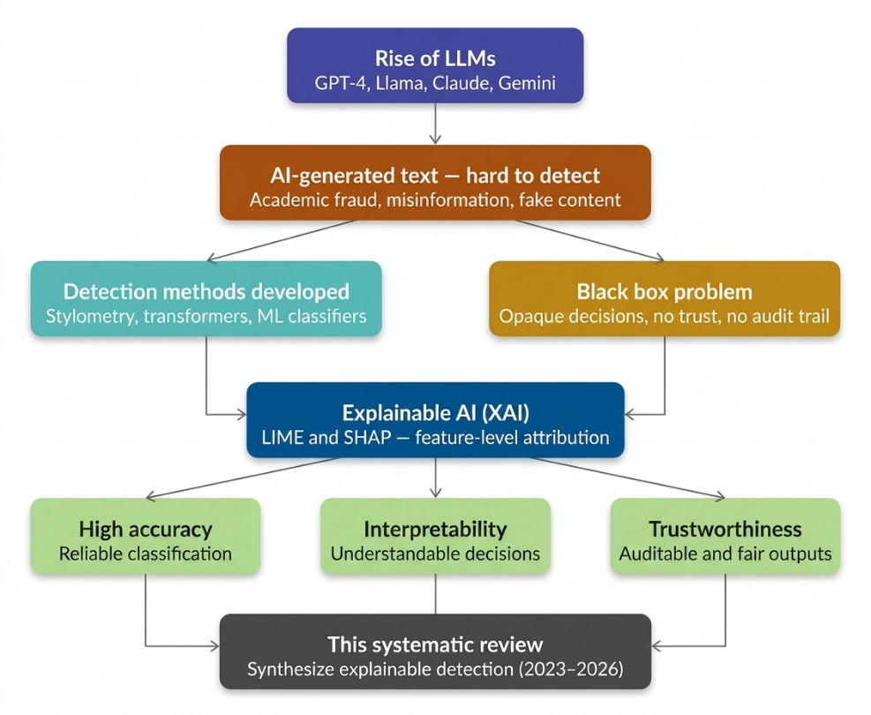
Two post-hoc local explanation methods have gained traction: LIME (Local Interpretable Model-agnostic Explanations) and SHAP (SHapley Additive exPlanations). Both are model-agnostic and provide feature-level attribution, enabling users to understand which linguistic properties drove a classification decision. Studies such as (Aditya Shah, 2023) and (Masih et al., 2025) demonstrate that LIME and SHAP can surface meaningful patterns — grammatical standardization, atypical word frequency distributions, punctuation anomalies — that consistently distinguish AI-generated from human-written text. (Najjar et al., 2025) further showed that XAI feature profiles can attribute text to specific LLMs, moving the field toward richer multi-label attribution.
Despite this progress, the literature remains fragmented across detection architectures, datasets, explainability methods, and domains. No comprehensive synthesis currently maps the full landscape of explainable AGTD across multiple LLMs, text domains, and XAI methodologies. This paper addresses that gap through a PRISMA-guided Systematic Literature Review (SLR), synthesizing research published between 2023 and 2026. The review is organized around three thematic clusters — stylometric and classical ML approaches, transformer-based deep learning methods, and multi-label attribution frameworks — examining LIME and SHAP not as transparency add-ons but as core analytical tools.
Figure 1: Classification of XAI approaches. Methods are divided into local vs. global scope and ante-hoc vs. post-hoc timing, with a primary emphasis on model-agnostic tools such as LIME and SHAP for individual prediction interpretation.

2. Background / Preliminaries
This section provides the foundational knowledge necessary to situate the review within its broader technical context, covering LLMs and text generation, AI-Generated Text Detection (AGTD), Explainable AI, LIME, SHAP, and benchmark datasets.

2.1 Large Language Models and Text Generation
Large Language Models are deep neural networks trained on vast text corpora to model the statistical structure of natural language. Built on the transformer architecture, modern LLMs such as GPT-4, Llama 3, Claude, and Google Gemini use self-attention mechanisms to capture long-range syntactic and semantic dependencies. Text generation is an autoregressive process: the model computes a probability distribution over its vocabulary and samples the next token iteratively. The temperature parameter governs output diversity. The result is text that is syntactically well-formed, contextually appropriate, and difficult to distinguish from human prose by unaided inspection. Human writing, by contrast, exhibits measurable irregularities — variations in rhythm, idiosyncratic word choice, and domain-specific stylistic fingerprints. LLM-generated text tends toward grammatical standardization and high lexical predictability — signals stylometric studies have identified as consistent markers of machine authorship (McGovern et al., 2024; Przystalski et al., 2025).

2.2 AI-Generated Text Detection (AGTD)
AGTD involves automatically classifying text as human-authored or machine-generated, or attributing it to a specific LLM source (Najjar et al., 2025; Zahraa J. Mohammed Ali 2025). The literature organizes detection approaches into three paradigms. Stylometric and classical ML methods use handcrafted linguistic features — syllable counts, POS distributions, readability indices — fed into SVM or Logistic Regression classifiers. These are interpretable but limited in capturing deep contextual patterns (Aditya Shah, 2023; McGovern et al., 2024). Transformer-based methods fine-tune models like RoBERTa and DistilBERT for high accuracy but sacrifice interpretability. Multi-label attribution and ensemble methods combine architectures to identify not just whether text is AI-generated, but which LLM produced it (Adilazuarda et al., 2023; Iqbal & Kashem, 2025).
Three benchmark datasets dominate the reviewed literature: HC3 (Human-ChatGPT Comparison Corpus) for binary classification; M4 for cross-lingual, multi-LLM evaluation; and HULLMI (Joshi et al., 2024), purpose-built for explainability-focused detection across multiple LLM sources.
Table 1: Benchmark datasets used across the twelve reviewed studies, with source, coverage, and primary evaluation use
Dataset | Source | Coverage | Primary Use
HC3 | Human + ChatGPT pairs | Multi-domain, English | Binary classification benchmark
M4 | Human + multiple LLMs | Multi-lingual, multi-model | Generalization testing
HULLMI | Human + GPT, Llama, others | Multi-source, English | Explainability-focused evaluation

2.3 Explainable Artificial Intelligence (XAI)
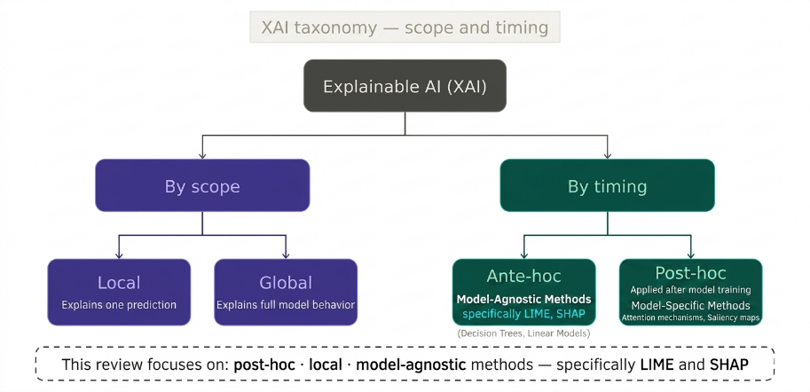
XAI refers to methods and principles that make ML model decisions understandable to human users. As AI systems are deployed in healthcare, law, and education, stakeholders must be able to inspect, audit, and contest automated decisions. XAI methods are categorized by scope (local vs. global) and timing (ante-hoc vs. post-hoc). Post-hoc local methods have proven most practical for AGTD, allowing interpretability to be layered onto high-performing transformer models without sacrificing accuracy (Joshi et al., 2024; Masih et al., 2025). This review focuses specifically on post-hoc, local, model-agnostic methods — LIME and SHAP.
Figure 2: Conceptual framework of the systematic review (2023–2026), illustrating the transition from the black-box challenges of LLM-generated text to interpretable and trustworthy detection via XAI.

2.4 LIME — Local Interpretable Model-Agnostic Explanations
LIME (Ribeiro et al., 2016) explains individual predictions by approximating a classifier's decision boundary locally with a simpler interpretable model. In text classification, LIME perturbs input by systematically masking words and observes how predictions change. A weighted linear model is fitted to this perturbation dataset, and its coefficients are reported as feature importances. Applied to AGTD, LIME identifies which tokens most strongly push the classifier toward an "AI" verdict. In the HULLMI framework (Joshi et al., 2024), LIME revealed that grammatical hedging and formulaic transitional phrases were the strongest indicators of LLM authorship for RoBERTa-Sentinel — transforming opaque binary outputs into auditable explanations.

2.5 SHAP — SHapley Additive Explanations
SHAP (Lundberg & Lee, 2017) is grounded in cooperative game theory. Each feature is treated as a "player" contributing to a joint outcome (the prediction), and Shapley values quantify each feature's marginal contribution across all possible feature subsets. SHAP values are additive and consistent — summing token-level values yields exactly the model's predicted probability. Positive values indicate a push toward AI-generated; negative values toward human authorship. (Przystalski et al., 2025) used SHAP to identify grammatical standardization and atypical word frequency distributions as the most persistently discriminative features of AI authorship across short-text samples.

2.6 LIME vs. SHAP — Key Differences
Both LIME and SHAP are post-hoc, local, and model-agnostic. LIME is faster and more flexible but can be unstable across runs due to random perturbation sampling. SHAP produces consistent, reproducible explanations grounded in mathematically guaranteed fair attribution but at significantly higher computational cost. In the reviewed literature, LIME is more commonly paired with transformer detectors where speed matters, while SHAP is preferred in stylometric settings requiring rigorous feature ranking (Aditya Shah, 2023; Masih et al., 2025; Mitrovi'c et al., 2023).

2.7 Benchmark Datasets
The three benchmark datasets described in Section 2.2 collectively serve as the empirical foundation for the reviewed studies. Their characteristics — size, diversity, and domain coverage — directly shape the generalizability claims each study can legitimately make.

3. Methodology for the Review

3.1 Overview — Systematic Literature Review and the PRISMA Framework
This review adopts a Systematic Literature Review (SLR) methodology — a structured, reproducible approach to synthesizing research evidence that minimizes selection bias and maximizes transparency. The guiding framework is PRISMA (Preferred Reporting Items for Systematic Reviews and Meta-Analyses), which provides a standardized checklist and flow structure for documenting each stage of the review process. Widely adopted in NLP systematic reviews as a gold-standard transparency mechanism (Adilazuarda et al., 2023), PRISMA ensures that the selection of twelve included studies is traceable, auditable, and reproducible.

3.2 Search Strategy
Four electronic databases were systematically searched: Google Scholar, ArXiv, IEEE Xplore, and SciSpace, selected for their complementary coverage of cross-disciplinary, formally published, and pre-print scholarship. Primary search strings included: "LLM text detection" AND "explainable AI"; "human vs AI text" AND "LIME OR SHAP"; "AI-generated text detection" AND "interpretability"; "transformer text classification" AND "feature attribution"; and "stylometry" AND "LLM detection". Spelling variations, synonymous terminology, and model-specific terms were incorporated to maximize recall. No restriction on publication type was applied at this stage.

3.3 Inclusion and Exclusion Criteria
Papers were evaluated in two sequential stages: title/abstract screening followed by full-text eligibility assessment. Inclusion required all four conditions: published between January 2023 and March 2026; directly addresses AI-generated text detection or attribution; incorporates or substantively discusses at least one explainability method; and written in English. Papers were excluded if they focused exclusively on non-textual modalities (image, audio, video); proposed detection systems with no reference to interpretability; used datasets below 500 samples; or lacked clearly reported evaluation metrics (accuracy, F1-score, or AUC).

3.4 PRISMA Flow
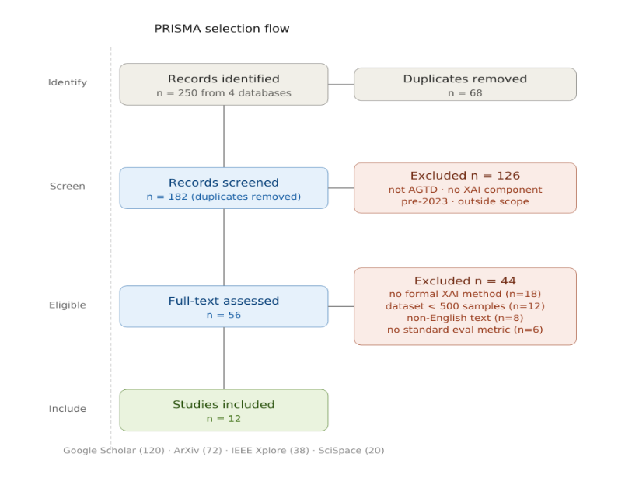
The paper selection pipeline proceeded as follows: 250 records were identified across four databases (Google Scholar: 120; ArXiv: 72; IEEE Xplore: 38; SciSpace: 20). After removing 68 duplicates, 182 records were screened at title/abstract stage; 126 were excluded (not AGTD, no XAI component, pre-2023, or outside scope). Of 56 full-texts assessed, 44 were excluded: no formal XAI method (n=18), dataset below 500 samples (n=12), non-English text (n=8), no standard evaluation metric (n=6). Twelve studies were included in the final synthesis.

3.5 Data Extraction
For each included study, data were extracted using a standardized template recording: detection architecture; explainability method; dataset(s) and sample size; evaluation metrics; primary discriminative linguistic features identified by XAI; and reported limitations. This template is reflected in the comparative tables presented in Sections 4 and 5.
Figure 3: PRISMA flow diagram showing the complete paper selection pipeline from 250 initially identified records across four databases to the 12 studies included in the final systematic synthesis, with exclusion reasons and counts at each stage.

3.6 Quality Assessment
Each included study was evaluated against four quality criteria adapted from the CASP framework: publication in a peer-reviewed venue (or pre-print subsequently cited by peer-reviewed work); dataset of at least 500 samples; reporting of at least one standard evaluation metric; and availability of replication materials. Studies meeting all four criteria were retained unconditionally. Those meeting three criteria were conditionally retained if the failing criterion was replication availability. All twelve final studies satisfy at least three of the four criteria.

3.7 Thematic Synthesis Approach
Given the heterogeneity of detection architectures, datasets, and evaluation conditions, this review adopts thematic synthesis rather than statistical meta-analysis. Findings are organized into three thematic clusters: stylometric and classical ML approaches, transformer-based deep learning methods, and multi-label attribution frameworks. Within each theme, studies are compared along detection accuracy, XAI method used, linguistic features identified, and reported limitations. The thematic structure maps directly onto the four research questions stated in Section 1, and contradictions between studies are foregrounded as productive directions for future research.

4. Literature Review / Thematic Analysis
The twelve included studies are organized into three thematic clusters. These clusters are not mutually exclusive but represent the dominant methodological orientations in the current literature. Studies are analyzed along four consistent axes: detection architecture, XAI method, discriminative linguistic features, and key limitations.
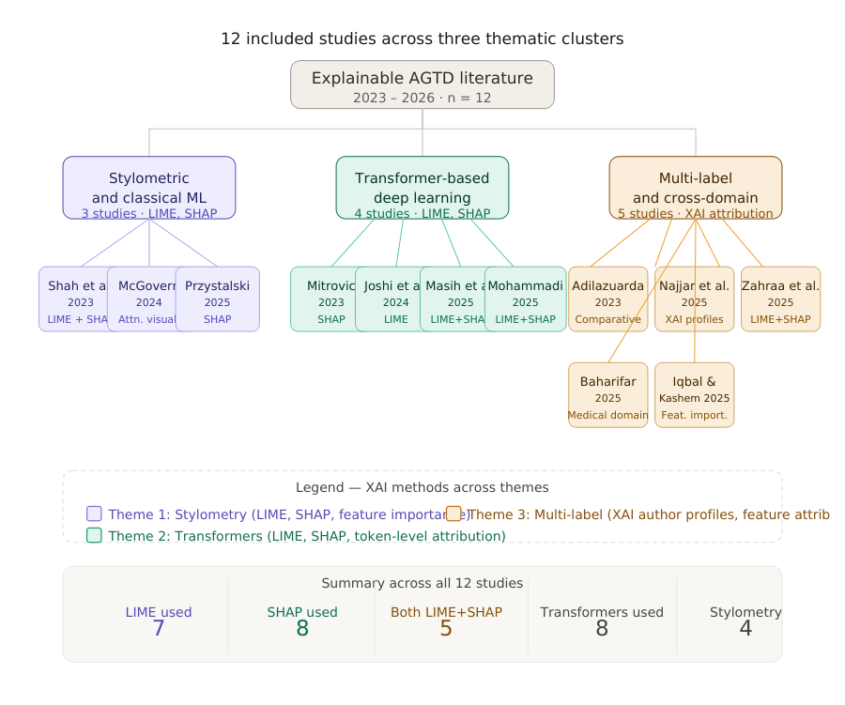
Figure 4: Overview of the 12 included studies distributed across three thematic clusters — stylometric and classical ML (purple), transformer-based deep learning (teal), and multi-label attribution (amber) — with associated XAI methods and summary statistics.

4.1 Theme 1 — Stylometric and Classical Machine Learning Approaches
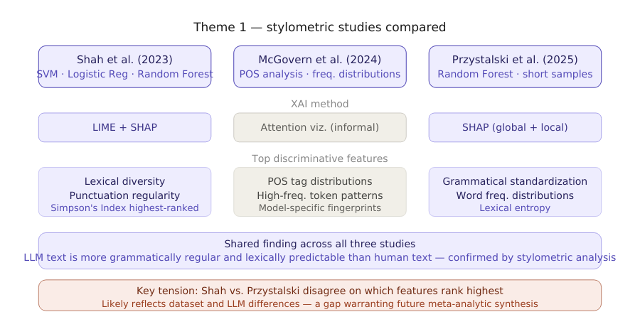
The earliest and most interpretable strand of AGTD relies on stylometry — quantitative analysis of writing style through handcrafted linguistic features — combined with conventional classifiers. Three studies fall within this cluster: (Aditya Shah, 2023), (McGovern et al., 2024), and (Przystalski et al., 2025). Together they establish the empirical foundation for understanding which surface-level linguistic properties most reliably distinguish human from LLM-generated text.
Figure 5: Comparison of the three Theme 1 stylometric studies (Shah et al., 2023; McGovern et al., 2024; Przystalski et al., 2025) across detection method, XAI tool applied, top discriminative features identified, and key shared finding versus unresolved tension

4.1.1 Aditya Shah et al. (2023) — Stylistic Features with LIME and SHAP
(Aditya Shah, 2023) provide one of the clearest demonstrations of how XAI transforms stylometric analysis from a black-box scoring exercise into a genuinely interpretable diagnostic. Working with a custom dataset of human-authored and AI-generated texts balanced across several domains, the authors train a suite of conventional classifiers — Support Vector Machines (SVM), Logistic Regression, and Random Forest — on a rich feature set drawn from stylometric analysis. Features included syllable count distributions, punctuation frequency ratios, lexical diversity indices such as Simpson's Index, average word length, and sentence length variance.
The application of both LIME and SHAP to explain resulting classifications revealed a consistent and meaningful pattern. LIME explanations at the token level showed that formulaic transitional phrases and low-entropy word choices were the strongest positive predictors of AI authorship. SHAP global feature attributions converged on a smaller set of high-signal features: Simpson's Index and punctuation regularity emerged as the two most consistently discriminative dimensions across all three classifiers. The convergence of both methods on the same underlying signal, despite using fundamentally different attribution mechanisms, substantially strengthens confidence in the finding. The primary limitation is dataset homogeneity — the corpus is English general-domain text, leaving open whether these stylometric signals remain discriminative in specialized domains such as legal writing or academic science, where human authors themselves write with high lexical regularity.

4.1.2 McGovern et al. (2024) — LLM Fingerprints through POS Distributions
Rather than building a binary classifier, (McGovern et al., 2024) investigate whether LLMs leave consistent, model-specific stylistic fingerprints. Analyzing texts generated by GPT-3.5, GPT-4, Llama, and several smaller models, they show that each LLM exhibits a characteristic part-of-speech (POS) tag distribution and a distinctive high-frequency token profile — patterns stable enough across prompts and domains to constitute a reliable authorial signature. Rather than applying formal XAI methods such as LIME or SHAP, the authors use attention weight visualization and frequency distribution plots, providing strong intuitive support for the claim that LLMs write differently from humans and from each other. In this sense, (McGovern et al., 2024) represents an important conceptual predecessor to the more formally explainable studies that follow — establishing the existence of discriminative stylometric patterns without providing a mathematically principled account of their relative importance. The authors themselves note this as a limitation, acknowledging that their visualization approach does not generalize to model-agnostic attribution. Despite this constraint, the finding that LLMs consistently over-represent adjective-noun sequences and passive constructions is directly actionable for detection system design and is subsequently corroborated by SHAP analysis in (Przystalski et al., 2025).

4.1.3 Przystalski et al. (2025) — Stylometry on Short Samples with SHAP
The most technically rigorous of the three Theme 1 studies, (Przystalski et al., 2025) address whether stylometric methods remain effective on short text samples, defined as passages of fewer than 200 words — a practically important challenge for social media posts, student short-answer responses, and peer review comments. Working with a carefully balanced corpus of short human-authored and LLM-generated texts across multiple genres, the authors train a Random Forest classifier on an extended stylometric feature set and apply SHAP for global and local feature attribution. SHAP global importance rankings identify three features as consistently dominant across all evaluated LLMs: grammatical standardization (operationalized as the ratio of grammatically correct constructions to total clauses), atypical word frequency distributions (measured as deviation from expected Zipfian rank-frequency curves), and lexical entropy.
The finding on grammatical standardization is particularly revealing. Human writing, even in short samples, exhibits measurable grammatical irregularity — sentence fragments, non-standard constructions, deliberate stylistic deviations. LLM-generated text adheres to grammatical norms with a consistency that is itself statistically anomalous. SHAP makes this mechanism explicit, revealing that grammatical standardization accounts for nearly twice the predictive weight of the next most important feature across short-sample scenarios. Taken together, the three Theme 1 studies converge on a coherent picture: stylometric features carry XAI-verifiable discriminative signal, and grammatical regularity and lexical predictability are the most persistent indicators of LLM authorship. The central tension — Shah et al. emphasize lexical diversity and punctuation regularity while Przystalski et al. prioritize grammatical standardization — likely reflects differences in dataset composition and the specific LLMs used, and constitutes a priority target for future meta-analytic synthesis.

4.2 Theme 2 — Transformer-Based Deep Learning Methods
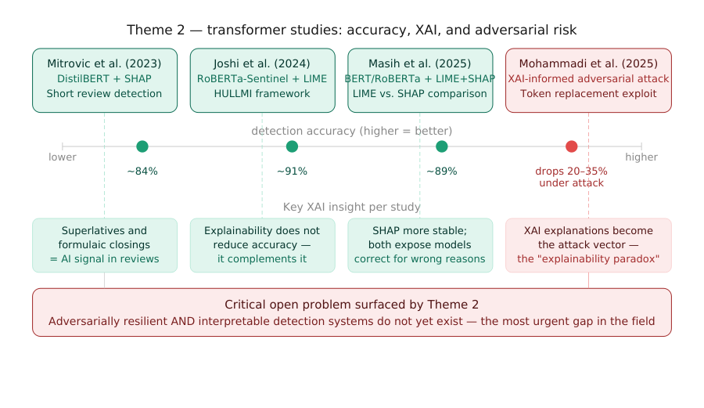
The second cluster encompasses four studies applying fine-tuned transformer architectures to the detection task, each incorporating post-hoc XAI to recover interpretability. This cluster is defined by a fundamental tension: transformers achieve substantially higher accuracy than stylometric methods, but their internal representations are far more difficult to interpret. One study — (Mohammadi et al., 2025) — reveals that resolving this tension introduces a serious new vulnerability.
Figure 6: Theme 2 transformer-based studies compared across detection accuracy, key XAI insight per study, and the adversarial paradox revealed by Mohammadi et al. (2025), in which XAI explanations simultaneously enable auditing and targeted evasion.

4.2.1 Mitrovic et al. (2023) — DistilBERT and SHAP for Short ChatGPT Reviews
One of the earliest transformer-based studies in this review, (Mitrovi'c et al., 2023) examine the specific challenge of detecting short ChatGPT-generated reviews — product and service evaluations of typically 50 to 150 words. Short texts provide fewer stylometric signals and less context for embedding-based models to exploit, making the detection task harder. The authors fine-tune DistilBERT — a lightweight, distilled variant of BERT — on a balanced dataset of human-written and ChatGPT-generated short reviews, achieving classification accuracy that substantially outperforms traditional ML baselines on the same data.
The integration of SHAP into this pipeline is methodologically notable. Applied at the token level, SHAP assigns importance values to individual words and subword tokens, revealing which specific linguistic elements most strongly activate the model's AI-generated classification signal. The results surface a coherent linguistic pattern: ChatGPT-generated reviews consistently over-produce evaluative superlatives ("exceptional", "outstanding", "perfect"), generic positive sentiment constructions, and formulaic closing phrases. Human reviews, by contrast, exhibit idiosyncratic vocabulary, hedged evaluations, and topic-specific references that the model recognizes as authentically personal. SHAP makes this reasoning transparent and auditable — a meaningful advance over a model that simply outputs a binary verdict. The study's primary limitation is its narrow domain scope: the discriminative features SHAP identifies in product reviews may not transfer to longer or more varied texts, and the authors do not evaluate cross-domain generalizability.

4.2.2 Joshi et al. (2024) — HULLMI: A Foundational Explainable Detection Framework
The HULLMI framework (Joshi et al., 2024) is the most architecturally comprehensive study in this review and serves as a structural reference for the field. HULLMI — Human vs. LLM Identification — evaluates multiple detection architectures, from Naive Bayes and Random Forest to fine-tuned transformer models, on a multi-source dataset containing texts from several LLMs alongside human-authored content across diverse domains.
The study's central finding is that RoBERTa-Sentinel — a domain-adapted variant of RoBERTa fine-tuned specifically for AI-text detection — achieves the highest classification performance (~91%) across all evaluated conditions. More significantly, the authors demonstrate that integrating LIME into the RoBERTa-Sentinel pipeline does not degrade performance but instead adds token-level transparency that makes individual decisions auditable. LIME explanations reveal that the model's highest-confidence predictions are driven by semantically coherent linguistic signals — formulaic hedging language, impersonal constructions, and overly smooth discourse transitions — rather than by spurious correlations or dataset artifacts. This positions explainability as a complement to accuracy rather than a trade-off with it, directly challenging the assumption that the most powerful models must necessarily be the least interpretable. HULLMI also establishes that detection accuracy varies considerably across LLMs — models trained primarily on GPT-generated text show 8–14 percentage point drops when applied to Llama-generated text — establishing cross-source generalization as a distinct and non-trivial challenge. The framework's primary limitation is its restriction to English-language texts and limited adversarial robustness testing.

4.2.3 Masih et al. (2025) — Combining Transformers with LIME and SHAP
(Masih et al., 2025) extend the HULLMI framework's explainability approach by systematically applying both LIME and SHAP to a broader set of transformer models — including BERT, RoBERTa, and a fine-tuned GPT-2 classifier — evaluated on a mixed corpus spanning academic writing, news articles, and social media content. The study's primary contribution is empirical rather than architectural: it provides the most comprehensive side-by-side comparison of LIME and SHAP as applied to transformer-based text detection currently available in the literature.
The comparison yields several practically significant observations. First, LIME and SHAP produce broadly consistent token-level attributions — the features each method identifies as most discriminative overlap substantially — which strengthens confidence in both methods as reliable explanatory tools. Second, SHAP produces more stable and reproducible explanations across runs than LIME, whose perturbation-based approach introduces variability when applied to high-dimensional transformer embeddings. Third, and perhaps most importantly, the study demonstrates that LIME and SHAP explanations can expose cases where a model is correct for the wrong reasons — where high classification confidence is driven by domain-specific vocabulary or topic signals rather than authentic stylistic markers of AI authorship. This capability for explanation-based error diagnosis has direct implications for model auditing and fairness assessment in academic integrity contexts. The study's main limitation is dataset scope: the mixed corpus does not include medical or legal text, leaving the generalizability of explainability findings to specialized domains unaddressed.

4.2.4 Mohammadi et al. (2025) — Adversarial Token Replacement using XAI
The fourth and most provocative study in this cluster, (Mohammadi et al., 2025) do not set out to build a better detector but to expose a critical vulnerability in existing ones. Their central insight is that the same XAI explanations that make detection decisions transparent can also serve as a roadmap for circumventing them. If LIME and SHAP identify which specific tokens most strongly signal AI authorship, then systematically replacing those tokens with semantically equivalent alternatives should reduce the model's confidence in its AI-generated classification without meaningfully changing the text's content.
The study validates this hypothesis empirically across multiple transformer-based detectors, including fine-tuned BERT and RoBERTa variants. XAI-informed token replacement reduces detection accuracy by between 20 and 35 percentage points on average, with minimal degradation in the semantic coherence of the modified text. The attack is effective, targeted, and executable without access to the detection model's internal weights — requiring only its classification output and the associated XAI explanation. This finding exposes what the authors term an "explainability paradox": the transparency that makes detection systems trustworthy and auditable simultaneously makes them vulnerable to informed adversarial manipulation. No practical defense mechanism is proposed, and the development of adversarially resilient detection systems that remain interpretable represents the field's most urgent frontier challenge.

4.3 Theme 3 — Multi-Label Attribution and Cross-Domain Generalization
The third cluster moves beyond binary human-versus-AI classification toward identifying which specific LLM produced a text and whether detection methods generalize across content domains. XAI plays a qualitatively different role here — not merely as a transparency mechanism, but as a core analytical tool for constructing author identity profiles.

4.3.1 Adilazuarda et al. (2023) — A Comparative Panorama
The broadest-scope study in this entire review, (Adilazuarda et al., 2023) conduct a systematic comparative analysis of detection paradigms — traditional ML, transformer-based models, and stylometric approaches — across multiple benchmark datasets including multilingual corpora. Rather than proposing a new system, the study synthesizes performance data across the literature to determine whether any single detection paradigm consistently dominates across domains and languages. The answer is unambiguous: no. Detection performance varies substantially across domains, LLMs, and text lengths, and no approach achieves consistently superior results across all conditions. Transformer-based methods lead in accuracy on single-domain, single-LLM benchmarks, but their advantage narrows or reverses on cross-domain and multilingual datasets. Stylometric methods, while less accurate on average, generalize more stably across domains. The study does not formally apply LIME or SHAP, but its finding that generalizability — not peak accuracy — is the field's most pressing unsolved challenge provides an essential empirical backdrop for the attribution studies that follow.

4.3.2 Najjar et al. (2025) — XAI for Multi-LLM Attribution
(Najjar et al., 2025) make one of the most conceptually significant contributions in this review. Rather than using XAI merely to explain a binary classification decision, they demonstrate that XAI feature importance profiles can be used to construct distinct "authorship signatures" for different LLMs — essentially fingerprinting each model's writing style through the lens of explainability. Working with a dataset containing texts from human authors alongside outputs from GPT-3.5, GPT-4, Llama, Gemini, and Claude, the authors train a transformer-based multi-label classifier and apply XAI attribution analysis to each model's predictions. The resulting feature importance profiles are model-specific and stable: GPT-4-generated texts are most strongly flagged by discourse-level coherence features and low syntactic variance, while Llama-generated texts are more prominently distinguished by vocabulary distribution patterns, and Gemini outputs by a characteristic avoidance of hedging language. Claude-generated texts show the strongest resemblance to human writing by several stylometric measures — a finding that carries direct implications for the difficulty of detecting outputs from the most capable current LLMs. The study establishes XAI attribution as a viable mechanism for source identification beyond binary classification — a genuinely novel contribution. Its principal limitation is the need for frequent retraining as LLMs evolve.

4.3.3 Zahraa J. Mohammed Ali (2025) — Multi-Label Classification with Transformer Embeddings
(Zahraa J. Mohammed Ali 2025) combine transformer embeddings with both LIME and SHAP in a unified pipeline designed to classify texts across several AI sources simultaneously. The study's architecture uses sentence-level transformer embeddings as input features to a multi-label classification head, with LIME providing local token-level explanations and SHAP providing global feature importance rankings across all label classes. The key finding is that XAI attribution granularity improves substantially at the multi-label level compared to binary classification: in the binary setting, SHAP identifies generic AI-authorship signals; in the multi-label setting, it surfaces source-specific patterns differentiating GPT-4-generated text from Llama-generated text through fine-grained differences in syntactic complexity and hedging frequency. This granular interpretability has direct practical value — an educator or journal editor can be shown not just that a text is AI-generated, but which model likely produced it and which specific linguistic features triggered that attribution. The study's main constraint is computational cost, as the multi-label transformer pipeline is substantially more expensive to run than binary classifiers, limiting deployment feasibility in resource-constrained settings.

4.3.4 Baharifar et al. (2025) — Medical Misinformation Detection
(Baharifar et al., 2025) address the identification of LLM-generated medical misinformation — a high-stakes domain where clinical writing is grammatically regular and stylistically constrained in ways that closely resemble LLM output, making standard stylometric signals unreliable. The authors address this through a multi-modal feature approach that combines textual stylometric and embedding-based features with structural metadata such as citation patterns and claim specificity scores. SHAP attributions reveal that LLM-generated medical misinformation is most reliably distinguished by its overuse of confident assertive constructions, its avoidance of appropriate epistemic hedging ("may", "suggests", "is consistent with"), and its tendency to state statistical claims without the numerical precision or source attribution characteristic of genuine clinical literature. These findings illustrate more broadly that domain-specific XAI analysis yields discriminative insights inaccessible to general-purpose detection approaches, with direct practical value for health communication authorities and medical journal editors.

4.3.5 Iqbal and Kashem (2025) — A Generalized ML Framework for Source Identification
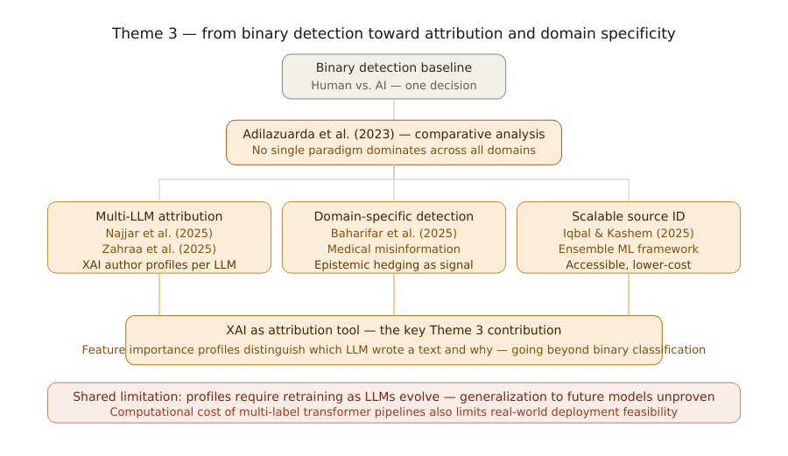
(Iqbal & Kashem, 2025) take a complementary approach to the attribution problem, proposing an ensemble machine learning framework specifically designed for scalable source identification across varied text types and multiple LLM sources. Rather than relying on computationally intensive transformer embeddings, their framework uses gradient-boosted ensemble classifiers trained on a hybrid feature set combining classical stylometric indices with TF-IDF-weighted lexical representations. Feature importance analysis reveals that cross-source attribution relies most heavily on vocabulary distribution divergence from expected human writing patterns, followed by sentence length consistency and connective phrase frequency. While the framework does not apply LIME or SHAP formally, it provides a computationally accessible baseline against which more expensive transformer-based attribution systems can be benchmarked. The study's primary limitation is scalability to newer LLMs: feature importance profiles trained on models available in 2024 may not transfer to next-generation systems such as GPT-5 or Llama 4.
Figure 7: Theme 3 progression from binary detection (Adilazuarda et al., 2023) toward multi-LLM attribution (Najjar et al., 2025; Zahraa et al., 2025), domain-specific detection (Baharifar et al., 2025), and scalable source identification (Iqbal & Kashem, 2025),

4.4 Cross-Thematic Synthesis
Four consistent patterns emerge across all three themes. First, LIME and SHAP consistently surface the same core linguistic signals — grammatical standardization, formulaic transitional language, low lexical entropy, and avoidance of epistemic hedging — regardless of detection architecture. This convergence across methodologically diverse approaches provides strong evidence that these features are genuine properties of LLM-generated text rather than dataset artifacts. Second, explainability and accuracy are complementary, not in tension: (Joshi et al., 2024) and (Masih et al., 2025) both demonstrate that LIME/SHAP integration does not degrade classification performance. Third, no study reports satisfactory cross-domain generalization — performance degrades across all paradigms when applied to unseen domains, as (Adilazuarda et al., 2023) document most comprehensively. Fourth, the adversarial vulnerability documented by (Mohammadi et al., 2025) remains unresolved — a paradox that future detection research must confront directly.

5. Comparative Analysis / Discussion
This section conducts a structured comparative analysis organized around the four research questions stated in Section 1, examining consensus and contradiction across the twelve reviewed studies.

5.1 RQ1 — How do the three detection paradigms compare in accuracy and interpretability?
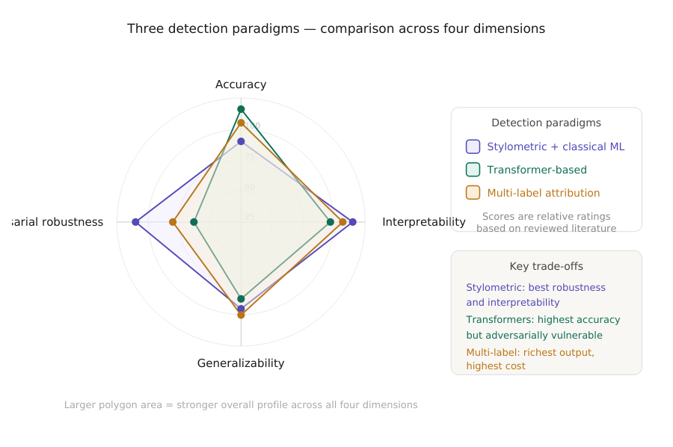
The accuracy-interpretability trade-off is more nuanced than a simple inverse relationship. Stylometric and classical ML approaches (Aditya Shah, 2023; McGovern et al., 2024; Przystalski et al., 2025) offer the highest baseline interpretability — feature sets are human-readable by design — with accuracy in the 80–87% range. Their generalization to unseen LLMs degrades faster than transformers because they rely on surface-level features that newer LLMs can increasingly avoid. Transformer-based approaches (Joshi et al., 2024; Masih et al., 2025; Mitrovi'c et al., 2023; Mohammadi et al., 2025) achieve peak accuracy (~91% for RoBERTa-Sentinel) but their interpretability deficit is recoverable through LIME and SHAP integration without accuracy sacrifice. The residual concern — XAI explanations opening an adversarial attack surface — is unique to this paradigm. Multi-label attribution frameworks (Adilazuarda et al., 2023; Baharifar et al., 2025; Iqbal & Kashem, 2025; Najjar et al., 2025; Zahraa J. Mohammed Ali 2025) produce the richest output — identifying which model produced a text — at the highest computational cost, with dependence on retraining as LLMs evolve. No paradigm dominates across all four dimensions of accuracy, interpretability, generalizability, and adversarial robustness. Paradigm selection should be driven by deployment context: high-stakes academic integrity settings may prioritize robustness and interpretability over peak accuracy, while large-scale content moderation may prioritize accuracy and scalability.
Figure 8: Radar chart comparing the three detection paradigms — stylometric and classical ML (purple), transformer-based (teal), and multi-label attribution (amber) — across four dimensions: accuracy, interpretability, cross-domain generalizability, and adversar

5.2 RQ2 — How effectively do LIME and SHAP identify discriminative linguistic features?
Across all twelve studies, LIME and SHAP demonstrate consistent ability to surface linguistically meaningful discriminative features — the strongest positive finding of this review. The consolidated feature table below summarizes top-ranked features across studies applying formal XAI attribution.
Table 2: Top-ranked discriminative linguistic features identified by LIME and/or SHAP across the twelve reviewed studies, with the studies reporting each feature and the detection paradigm in which it was identified. Grammatical standardization is the single mo
Discriminative Feature | Studies Identifying It | Paradigm
Grammatical standardization | Przystalski (2025), Masih (2025), Baharifar (2025) | All three
Formulaic transitional phrases | Shah (2023), Joshi (2024), Zahraa (2025) | Stylometric, Transformer
Low lexical entropy / predictable vocabulary | Shah (2023), Przystalski (2025), Iqbal (2025) | Stylometric, Ensemble
Superlatives and assertive constructions | Mitrovic (2023), Baharifar (2025) | Transformer
Absence of epistemic hedging | Baharifar (2025), Najjar (2025) | Multi-label, Domain
POS tag distribution anomalies | McGovern (2024), Przystalski (2025) | Stylometric
Discourse-level coherence over-smoothing | Joshi (2024), Najjar (2025) | Transformer, Multi-label
Grammatical standardization is the single most consistently reported feature, appearing across all three paradigms in studies using both LIME and SHAP. This convergence across fundamentally different attribution mechanisms — perturbation-based in LIME, marginal contribution-based in SHAP — constitutes particularly strong evidence of a genuine and stable property of LLM-generated text. SHAP and LIME agree on feature rankings in the majority of studies applying both (Masih et al., 2025), with disagreements concentrated in mid-ranked features rather than the top signals. Most importantly, the features surfaced by XAI analysis reveal a coherent linguistic theory of AI authorship: LLM text is more regular, more formulaic, more assertive, and less epistemically cautious than authentic human prose — providing practitioners a basis for targeted detection heuristics independent of any particular model or dataset.

5.3 RQ3 — What does the literature reveal about generalizability?
Generalizability — the ability of a detection system to maintain performance when applied to LLMs, text domains, or sample lengths not seen during training — is the most consistently problematic dimension across the entire reviewed literature. Every study evaluating cross-domain or cross-LLM performance reports significant degradation, and no study proposes a fully satisfactory solution.
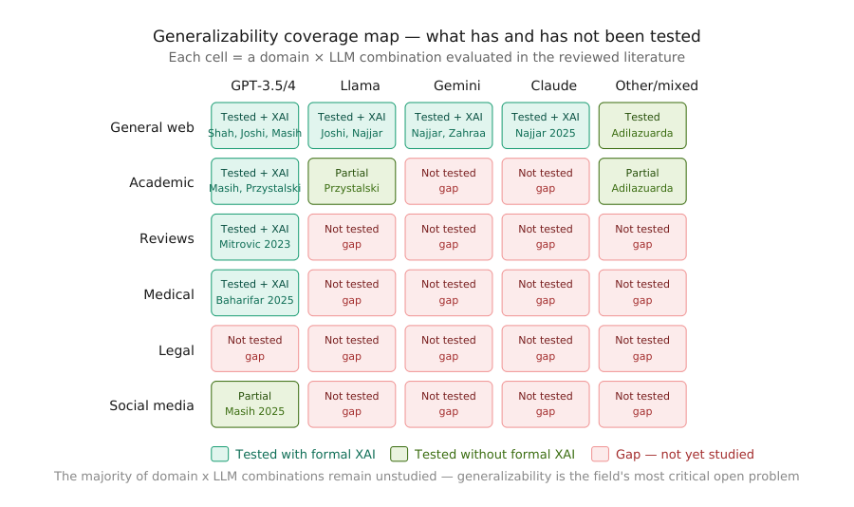
The nature of the generalization failure differs across paradigms. For stylometric methods, the failure mode is feature drift: the specific lexical and syntactic patterns that discriminate AI from human text in one domain — general web text — may be absent or reversed in another where human writing is itself highly regularized, such as legal contracts or clinical case reports. (Przystalski et al., 2025) note that stylometry's short-text performance advantage may not extend to professional writing contexts where brevity and formality are human-imposed rather than AI-characteristic. For transformer-based methods, the failure mode is distributional shift: (Joshi et al., 2024) document accuracy drops of 8–14 percentage points when a GPT-focused detector is applied to Llama-generated text. The LIME explanations for these cross-LLM failures are revealing — the misclassified texts are rejected because the model fails to activate on the source-specific linguistic features it learned during training, rather than because those texts lack AI-authorship signals altogether. For multi-label attribution frameworks, the failure mode is model version sensitivity: the authorship profiles constructed by (Najjar et al., 2025) and (Zahraa J. Mohammed Ali 2025) are contingent on specific model versions and require retraining as LLMs are updated or replaced, creating a maintenance burden that limits the practical durability of attribution-based systems.
Figure 9: Generalizability coverage map showing which domain-by-LLM evaluation combinations have been studied with formal XAI (teal), studied without formal XAI (green), or remain completely unstudied (coral/red). The map reveals that the legal domain is entirely
The vast majority of domain-by-LLM evaluation combinations remain completely unstudied — the entire legal domain has not been evaluated by any study in this review, constituting a fundamental limitation on the trustworthiness of current detection systems when deployed outside controlled research conditions.

5.4 RQ4 — What are the most significant limitations of current explainable detection frameworks?
Four structural limitations emerge from the synthesis. The first is adversarial vulnerability. As established by (Mohammadi et al., 2025), XAI-informed token replacement represents a practically executable and highly effective attack on transformer-based detectors. What makes this limitation particularly serious is that it is not incidental to any specific model choice — it is a structural consequence of making detection systems interpretable. Any system transparent enough to explain its decisions is, by that same transparency, providing a roadmap for evasion. No study in this review proposes a mechanism that simultaneously maintains interpretability and robustness against this attack.
The second is the absence of standardized evaluation benchmarks for explainability itself. Every study evaluates detection performance using accuracy, F1, and AUC, but none applies a standardized metric for explanation quality. How faithfully does a LIME explanation represent the model's actual decision process? How stable is a SHAP attribution across semantically equivalent phrasings? How human-interpretable are token-level attributions in practice? These questions remain unanswered, leaving comparisons of explainability quality across studies impressionistic rather than empirical.
The third is systematic bias risk against non-native English speakers and highly specialized writers. The discriminative features surfaced by XAI — grammatical standardization, formulaic transitions, low lexical entropy — are equally characteristic of non-native speakers, professionals writing in codified registers such as clinical medicine and legal documentation, and students writing under examination conditions. Several studies note this risk in passing — (Masih et al., 2025) flag it as a fairness concern — but none evaluates it empirically. The potential for detection systems to systematically flag non-native English writing as AI-generated represents a significant ethical liability the current literature has not adequately addressed.
The fourth is evaluation metric homogeneity. The reviewed literature relies almost exclusively on accuracy and F1-score, treating all misclassifications equally. In the context of AGTD, however, false positives — incorrectly classifying human writing as AI-generated — carry far greater institutional consequences than false negatives. A student falsely accused of AI-assisted cheating faces academic penalties; a journal submission incorrectly rejected represents a reputational harm. The field needs evaluation frameworks that reflect this asymmetry, incorporating false positive rate at specified recall levels and cost-sensitive classification metrics.

5.5 Integrative Discussion — Toward Trustworthy Explainable Detection
Three integrative observations synthesize the findings across all four research questions. First, explainability has graduated from optional add-on to core design component. (Joshi et al., 2024) and (Masih et al., 2025) establish that XAI integration requires no accuracy sacrifices, removing the most commonly cited objection to mandating explainability. Second, the field's most tractable next step is the development of domain-specific, multi-LLM benchmark datasets with standardized XAI evaluation protocols — a shared benchmark covering legal, academic, and medical text across GPT, Llama, Gemini, and Claude would address the three most significant methodological gaps simultaneously. Third, the adversarial paradox (Mohammadi et al., 2025) cannot be resolved by any method currently in the literature. This suggests the field may need to move beyond detection systems as standalone tools toward detection ecosystems — combining automated classification, human expert review, institutional policy, and provenance-based authentication — in which no single component bears the full burden of trustworthiness.

6. Research Gaps and Future Directions
The comparative analysis identified four structural limitations. This section develops each into a concrete research agenda, treating each gap as a problem with a stated nature, documented evidence base, and proposed direction. A prioritized roadmap closes the section.

6.1 Gap 1 — The Adversarial Robustness Problem
Nature of the gap.
The explainability paradox documented by (Mohammadi et al., 2025) represents the most technically urgent unresolved problem in the field. XAI-informed token replacement reduces the accuracy of state-of-the-art transformer detectors by 20–35 percentage points with minimal impact on text coherence, using only the model's classification output and its associated LIME or SHAP explanation as inputs. No current detection architecture is simultaneously robust against this attack and interpretable.
Why existing approaches fall short.
Adversarial training — augmenting datasets with perturbed examples so the model learns to resist them — demonstrates effectiveness in image classification but transfers poorly to text, where the perturbation space is discrete and semantically constrained. More fundamentally, adversarial training in text detection faces a moving-target problem: as LLMs improve, the space of plausible token substitutions expands, and adversarial training sets rapidly become stale. No study in this review attempts adversarial training for XAI-robust text detection, and the theoretical conditions under which such training could succeed remain uncharacterized.
Proposed direction.
Future research should explore two complementary approaches. First, explanation-aware detection architectures — models whose training objective explicitly penalizes the ability of explanation-guided perturbations to shift classification output, jointly optimizing accuracy and explanation stability under targeted token substitution. Second, ensemble-based detection with distributed attribution, in which multiple independent detectors are combined such that XAI explanations from one model do not provide a complete evasion blueprint for the ensemble as a whole. The intuition is that an adversary exploiting SHAP attributions from model A will not necessarily evade model B's decision boundary, and the ensemble's combined verdict will be harder to game than any individual component.

6.2 Gap 2 — Absence of Standardized XAI Evaluation Benchmarks
Nature of the gap.
The field lacks shared protocols for answering three distinct questions about XAI outputs: faithfulness (does the explanation accurately represent what the model actually computed?), stability (does the same text always produce the same explanation?), and interpretability (do the explanations actually help human users make better-informed decisions?). Without answers to these questions, the claim that a detection system is "explainable" remains qualitative and unverifiable.
Why existing approaches fall short.
Current XAI evaluation in AGTD relies on two informal proxies: visual inspection of feature importance plots, and post-hoc agreement between LIME and SHAP on top-ranked features. (Masih et al., 2025) demonstrate that LIME and SHAP tend to agree on the strongest signals, providing some corroborative evidence of faithfulness, but this is a consistency check rather than a faithfulness test. Faithfulness requires comparison between the explanation and the model's actual internal computation — a comparison that none of the reviewed studies formally performs. Human interpretability — whether the explanations actually help educators or editors make better-informed decisions — has not been evaluated by any study in this review at all.
Proposed direction.
The most impactful single contribution the field could make is the development and adoption of a shared XAI evaluation protocol for AGTD, analogous to the role that GLUE and SuperGLUE play in general NLP. Such a protocol should include: automated faithfulness metrics based on input occlusion or gradient-based comparison with model internals; stability metrics measuring explanation consistency across semantically equivalent paraphrases; and human evaluation studies in which domain practitioners — educators, journal editors, legal professionals — are given explanations and assessed on whether those explanations improve their detection decision accuracy relative to receiving the raw classification output alone.

6.3 Gap 3 — Fairness and Bias Against Non-Native and Specialized Writers
Nature of the gap.
The discriminative features most consistently identified by XAI across the reviewed literature — grammatical standardization, formulaic transitional language, low lexical entropy, avoidance of epistemic hedging — are not exclusive markers of LLM authorship. They are equally characteristic of writing produced under conditions of linguistic constraint: non-native English speakers, professionals writing in highly codified registers such as clinical medicine and legal documentation, and students writing under examination conditions. The risk that current detection systems systematically flag this population as AI-generated is acknowledged in passing by (Masih et al., 2025) and implicitly noted by (Baharifar et al., 2025), but has not been empirically evaluated by any study in this review.
Why existing approaches fall short.
Benchmark datasets — HC3, M4, HULLMI — are constructed primarily from fluent native-speaker human text paired with LLM-generated text. This construction ensures the stylistic contrast is as sharp as possible for training, but systematically excludes populations whose human prose stylistically overlaps with LLM output. No study evaluates false positive rates for non-native English speakers, professional technical writers, or writers operating under high-constraint conditions — an omission that constitutes a significant ethical gap given the deployment of detection systems in academic integrity contexts globally.
Proposed direction.
Future research should pursue two interconnected directions: bias audit methodology, which develops standardized procedures for measuring differential false positive rates across demographic and linguistic subgroups; and explanation-based debiasing, which uses SHAP and LIME attributions to identify the specific features driving false positive classifications in constrained writing and develops correction mechanisms through feature reweighting, post-hoc calibration, or auxiliary classifiers. XAI is uniquely positioned to enable this debiasing work, since it makes the specific mechanism of systematic misclassification visible and therefore addressable.

6.4 Gap 4 — Cross-Domain and Cross-LLM Generalization
Nature of the gap.
As the generalizability coverage map in Section 5 illustrates, the vast majority of domain-by-LLM evaluation combinations remain completely unstudied. Detection systems evaluated exclusively on general-domain text achieve performance figures that do not transfer reliably to specialized domains, and systems trained on one LLM's outputs show degraded performance when tested on another's — the central practical constraint on deployment in real-world institutional settings where texts will routinely differ in domain and LLM source from the training distribution.
Why existing approaches fall short.
The generalization problem has not been systematically studied as a research question in its own right — most studies treat poor cross-domain performance as a limitation to be acknowledged rather than a mechanism to be understood. The XAI tools available could in principle illuminate why generalization fails: if SHAP attributions reveal that a model classifies medical writing based on domain-specific vocabulary rather than LLM-characteristic stylistic features, that diagnosis directly informs a mitigation strategy. No study in this review uses XAI analysis in this diagnostic capacity — a missed opportunity representing a clear direction for future work.
Proposed direction.
Three complementary directions are warranted. First, XAI-guided domain adaptation: using explanation analysis to identify which learned features represent genuine LLM stylistic signatures versus domain-specific artifacts. Second, meta-learning for detection generalization: training detection systems using few-shot adaptation techniques that allow rapid performance recovery on new domains or LLMs with minimal labeled data. Third, longitudinal evaluation studies tracking detection performance over time as LLMs evolve, providing the empirical basis for understanding how quickly systems become outdated and how XAI-identified features change across model generations.

6.5 Gap 5 — Multilingual Detection with Explainability
Nature of the gap.
None of the twelve reviewed studies applies formal XAI methods to non-English text. (Adilazuarda et al., 2023) note that multilingual detection receives partial coverage in their comparative survey, but detection challenges in other languages may differ fundamentally from those studied in the English-centric literature — due to differences in morphological complexity, syntactic structure, and the relative size of LLM training data across languages. This gap represents a significant limitation on the international applicability of the reviewed findings.
Proposed direction.
Future work should develop multilingual explainable detection benchmarks pairing human and LLM-generated text across typologically diverse languages, evaluating whether the stylometric features identified as discriminative in English transfer across languages or whether language-specific features dominate. The application of LIME and SHAP to multilingual transformer models such as mBERT and XLM-RoBERTa would provide the first systematic characterization of cross-lingual XAI attribution in AGTD.

6.6 Prioritized Research Roadmap
Gaps 2, 3, and 4 fall in the high urgency, high feasibility quadrant — making them the natural starting point for the research community with methods already available. Gap 5 (multilingual detection) is somewhat less urgent but equally feasible as a near-term target. Gap 1 (adversarial robustness) is the most urgent but requires architectural innovations that do not yet exist — partial mitigations are worth pursuing immediately while a full solution remains on a longer horizon.

6.7 Summary of the Research Agenda
Three principles unify the five gaps. First, explainability must be treated as a measurable property with its own evaluation standards — Gap 2 is a prerequisite for meaningful progress on all others. Second, detection systems must be evaluated on the populations they will actually affect — Gaps 3 and 5 expand the evaluation perimeter to constrained writers and non-English text. Third, robustness and transparency must be pursued jointly rather than traded off — Gap 1 frames this as a concrete joint optimization problem. The field possesses the methodological tools to make substantial progress on Gaps 2, 3, 4, and 5 within a realistic research horizon. Gap 1 requires more fundamental innovation, but the adversarial paradox is now sufficiently characterized to serve as a concrete target for the next generation of detection architectures.

7. Conclusion
The detection of LLM-generated text has evolved rapidly from a niche classification problem into one of the most consequential challenges in contemporary NLP. The central argument of this review is that explainability is not an optional enhancement to AGTD — it is a prerequisite for trustworthy deployment wherever the stakes of misclassification are real. This systematic review has synthesized twelve studies published between 2023 and 2026 across three thematic clusters, analyzed through the consistent lens of how LIME and SHAP contribute to making detection decisions interpretable, auditable, and fair.
The principal positive finding is convergent validity: LIME and SHAP, applied across architecturally diverse detection systems and varied datasets, consistently surface the same core linguistic markers of LLM authorship — grammatical standardization, formulaic transitional language, low lexical entropy, and suppressed epistemic hedging. This convergence across fundamentally different attribution mechanisms provides strong evidence that these features reflect genuine and stable properties of machine-generated prose.
The principal critical finding is equally clear: the field has not yet reconciled transparency with robustness. The adversarial paradox documented by (Mohammadi et al., 2025) remains unresolved, and no current architecture achieves both properties together. The generalizability coverage map from Section 5 reveals that the majority of domain-by-LLM evaluation combinations remain completely unstudied, and the fairness implications for non-native English speakers and specialized professional writers have received acknowledgement but no empirical investigation.
These findings carry direct implications: accuracy alone is an insufficient criterion for institutional deployment; explainability quality should be measured with standardized metrics; evaluation must cover the populations a system will actually affect; and adversarial robustness should be pursued jointly with interpretability, not addressed separately after the fact. The five-gap research agenda proposed in Section 6 provides a concrete and prioritized path forward. Progress on Gaps 2, 3, 4, and 5 is achievable with existing methodological tools; Gap 1 requires more fundamental architectural innovation.
In a world where LLM-generated content is increasingly embedded in academic, journalistic, medical, and legal discourse, the ability to detect and explain AI authorship transparently is not merely a technical capability — it is a governance requirement. The goal is detection systems that are not only accurate, but honest about how they know what they know — systems whose reasoning can be examined, challenged, and trusted.

10. References
Adilazuarda, F., Arkoulis, N. N., & Chumakov, O. (2023). Beyond Turing: A comparative analysis of approaches for detecting machine-generated text. ArXiv, abs/2311.12373. https://doi.org/10.48550/arXiv.2311.12373
Aditya Shah, P. R., Urmi Dedhia, Shruti Prasad, Siddhi Muni and Kiran Bhowmick. (2023). Detecting and unmasking AI-generated texts through Explainable Artificial Intelligence using stylistic features. International Journal of Advanced Computer Science and Applications (IJACSA), 14(10). https://doi.org/10.14569/IJACSA.2023.01410110
Baharifar, M., Kujur, A., & Monfared, Z. (2025). Interpretable AI for classifying Human-and LLM-generated medical misinformation with multi-modal features 2nd Sorbonne-Heidelberg Workshop on AI in medicine, Heidelberg, Germany.
Iqbal, M. S., & Kashem, M. A. (2025). A machine learning framework for identifying sources of AI-generated text. Statistics, Optimization & Information Computing, 13(5), 2186-2204. https://doi.org/10.19139/soic-2310-5070-2225
Joshi, P. D., Pocker, S., Dandekar, R. A., Dandekar, R. A., & Panat, S. (2024). HULLMI: Human vs LLM identification with explainability. ArXiv, abs/2409.04808. https://doi.org/10.48550/arXiv.2409.04808
Lundberg, S. M., & Lee, S.-I. (2017). A Unified Approach to Interpreting Model Predictions. Neural Information Processing Systems,
Masih, A., Afzal, B., Firdoos, S., Mahmood, J., Ali, A., Abdulnabi, M. S., & Balungu, D. M. (2025). Classifying human vs. AI text with machine learning and explainable transformer models. Scientific Reports, 15(1), 43310. https://doi.org/10.1038/s41598-025-27377-z
McGovern, H., Stureborg, R., Suhara, Y., & Alikaniotis, D. (2024). Your large language models are leaving fingerprints. ArXiv, abs/2405.14057. https://doi.org/10.48550/arXiv.2405.14057
Mitrovi'c, S., Andreoletti, D., & Ayoub, O. (2023). ChatGPT or Human? Detect and explain. Explaining decisions of machine learning model for detecting short chatgpt-generated text. ArXiv, abs/2301.13852. https://doi.org/10.48550/arXiv.2301.13852
Mohammadi, H., Giachanou, A., Oberski, D. L., & Bagheri, A. (2025). Explainability-based token replacement on llm-generated text. arXiv preprint arXiv:2506.04050. https://doi.org/10.48550/arXiv.2506.04050
Najjar, A. A., Ashqar, H. I., Darwish, O., & Hammad, E. (2025). Leveraging explainable ai for llm text attribution: Differentiating human-written and multiple llm-generated text. Information, 16(9), 767. https://doi.org/10.48550/arXiv.2501.03212
Przystalski, K., Argasiński, J. K., Grabska-Gradzińska, I., & Ochab, J. (2025). Stylometry recognizes human and LLM-generated texts in short samples. Expert Systems with Applications, 129001. https://doi.org/10.48550/arXiv.2507.00838
Ribeiro, M. T., Singh, S., & Guestrin, C. (2016). “Why Should I Trust You?”: Explaining the Predictions of Any Classifier. Proceedings of the 22nd ACM SIGKDD International Conference on Knowledge Discovery and Data Mining.
Zahraa J. Mohammed Ali , S. A. Y. (2025). Interpretable multi-label classification of human- and large language model-generated texts using transformer embeddings and explainable artificial intelligence. Ingénierie des Systèmes d’Information, 30(12), 14. https://doi.org/10.18280/isi.301203

